# Lab: Objects and Classes

## Person Info

Write a function that receives **3 parameters**, sets them to an **object** and prints the object's properties by key and value in the format: "**{key}: {value}**"

The input comes as **3 separate strings** in the following order: **firstName**, **lastName**, **age**.

### Examples

|  |  |
| --- | --- |
| **Input** | **Output** |
| "Peter",  "Pan", "20" | firstName: Peter  lastName: Pan  age: 20 |

### Hints

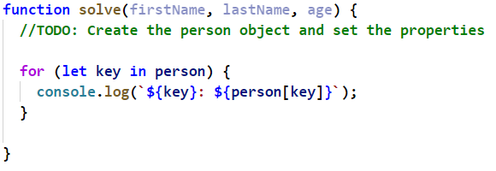

## City

Receive **five single strings**.

Create a **city object** which will hold the city **name**, **area**, **population**, **country** and **postcode**.

Loop through all the **keys** and print them with their **values** in format: "**{key} -> {value}**"

The input will be in the following order: **name**, **area**, **population**, **country** and **postCode**.

See the examples below.

### Examples

|  |  |
| --- | --- |
| **Input** | **Output** |
| "Sofia"," 492", "1238438", "Bulgaria", "1000" | name -> Sofia  area -> 492  population -> 1238438  country -> Bulgaria  postCode -> 1000 |

## Convert to Object

Write a function that receives a **string** in **JSON format** and converts it to **object**.

Loop through all the keys and print them with their values in format: "**{key}: {value}**"

### Examples

|  |  |
| --- | --- |
| **Input** | **Output** |
| '{"name": "George", "age": 40, "town": "Sofia"}' | name: George  age: 40  town: Sofia |

### Hints

* Use **JSON.parse()** method to parse JSON string to an object

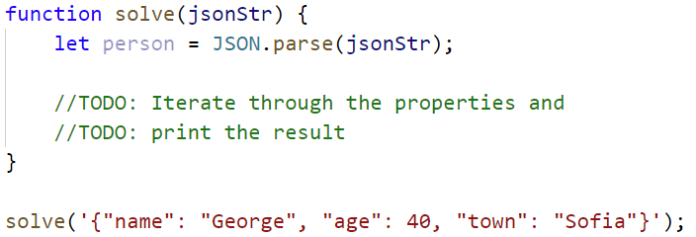

## Convert to JSON

Write a Function That Receives Name, LastName, HairColor and Sets Them to an Object.

Convert the **object** to **JSON string** and print it.

Input is provided as **3 single strings** in the order stated above.

### Examples

|  |  |
| --- | --- |
| **Input** | **Output** |
| 'George',  'Jones',  'Brown' | {"name":"George",  "lastName":"Jones",  "hairColor":"Brown"} |

### Hints

* Use **JSON.stringify()** to parse the object to JSON string

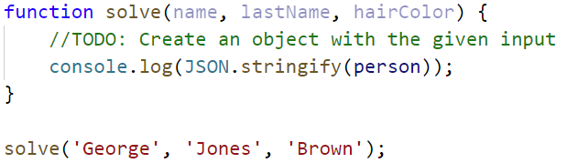

## Cats

Write a function that receives **array** of strings in the following format **'{cat name} {age}'**.

Create a **Cat** **class** that receives in the **constructor** the **name** and the **age** parsed from the input.

It should also have a function named **"meow"** that will print **"{cat name}, age {age} says Meow"** on the console.

For each of the strings provided you must **create a cat object.**

### Examples

|  |  |
| --- | --- |
| **Input** | **Output** |
| ['Mellow 2', 'Tom 5'] | Mellow, age 2 says Meow  Tom, age 5 says Meow |

### Hints

* Create a Cat class with properties and methods described above
* Parse the input data
* Create all objects using class constructor and the parsed input data, store them in an array
* Loop through the array using **for…of** cycle and **invoke .meow()** method

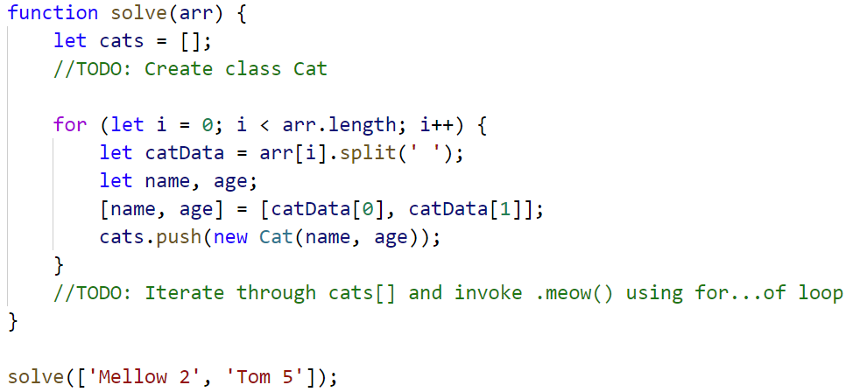

## Songs

Define a **class** **Song**, which holds the following information about songs: **typeList**, **name** and **time**.

You will receive the input as an **array**.

The first element **n** will be the number of songs. Next **n** elements will be the songs data in the following format: **"{typeList}_{name}_{time}"**, and the the last element will be **Type List** / **"all".**

Print only the **names of the songs** which are from that **Type List** / **All songs**.

**Examples**

|  |  |
| --- | --- |
| **Input** | **Output** |
| [3,  'favourite_DownTown_3:14',  'favourite_Kiss_4:16',  'favourite_Smooth Criminal_4:01',  'favourite'] | DownTown  Kiss  Smooth Criminal |
| [4,  'favourite_DownTown_3:14',  'listenLater_Andalouse_3:24',  'favourite_In To The Night_3:58',  'favourite_Live It Up_3:48',  'listenLater'] | Andalouse |
| [2,  'like_Replay_3:15',  'ban_Photoshop_3:48',  'all'] | Replay  Photoshop |

### Solution:

Create a Song class with properties described above

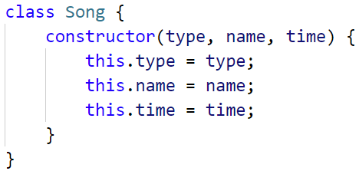

Create a new array, where you will store songs

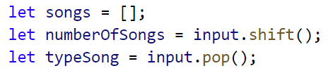

Iterate over the songs:

